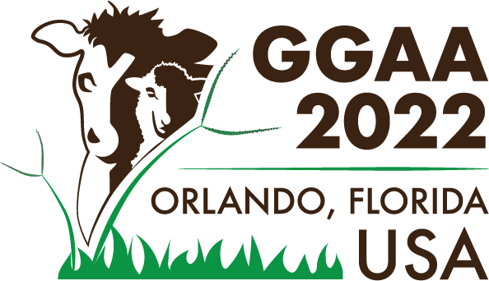
OPTIONAL GGAA 2022 Workshop:

Meeting the Challenge of Reducing Enteric CH4 Emissions from Sub-Saharan Africa
Sunday, June 5, 2022 | 1:00PM – 5:00PM | Orlando, Florida, USA
(There is no cost to participate but space is limited. Advance registration is required.)

w w w . c o n f e r e n c e . i f a s . u f l . e d u / G G A A

African countries contribute to about 10% of enteric CH4 emissions from dairy cattle worldwide despite producing only 3.9% of the world’s milk. This is because livestock production in most Sub-Saharan African countries, by virtue of being dependent on low quality crop residues, leads to very high levels of enteric methane per unit of product, as compared to livestock systems in developed regions. Methane also represents an important loss of energy that could be otherwise channeled into growth or milk production by ruminants.

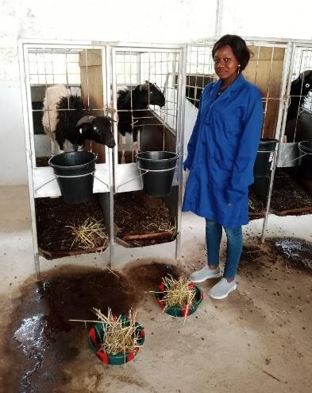
Join us at this interactive workshop to:
- Discuss findings on emissions of local cattle and small ruminant breeds.
- Explore different livestock systems scenarios for reducing enteric CH4 emissions.
- Highlight measures that would be most applicable to mitigate emissions while supporting and possibly improving livestock productivity.

This workshop format provides an excellent opportunity to network with researchers from partner organizations from several of the countries in which the Livestock Systems Innovation Lab (LSIL) operates.
About the Feed the Future Innovation Lab for Livestock Systems (LSIL)
The U.S. Government established several Innovation Labs as part of its Feed the Future global hunger and food security initiative to equip people with the knowledge and tools they need to feed themselves, giving families and communities in some of the world’s
poorest countries the freedom and opportunity to lift themselves out of food insecurity and malnutrition.
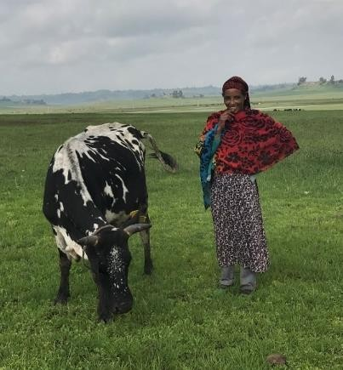
Established in 2015 with funding from United States Agency for International Development (USAID), LSIL built a global network of researchers and in-country stakeholders from over 100 institutions, and together these thought-leaders established research priorities based on needs and opportunities within local livestock systems in six target countries.
Snapshot of LSIL Achievements: The nutrition of vulnerable families and local farming practices have improved in targeted areas. This progress was achieved by awarding grants to global partners that involved more than 16,500 participants; over 50 research- based innovations that are used by over 4,200 people; over 50 scientific journal articles including special issues of 3 journals; by supporting over 140 university students worldwide; and by fostering knowledge-sharing and direct idea exchanges in developing countries.
Visit our website to learn more. https://livestocklab.ifas.ufl.edu

About the Workshop Organizer
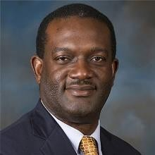
Dr. Gbola Adesogan is a Professor of Animal Nutrition and Director of the Food Systems Institute at the University of Florida’s Institute of Food and Agricultural Sciences (IFAS). He is also the Director and Principal Investigator of the Feed the Future Innovation Lab for Livestock Systems (LSIL). His research interests include sustainable improvement of livestock production, using animal-source foods to improve human nutrition and health, improving the quality, conservation, and utilization of forages to improve animal production and welfare; using feed additives to improve manipulate rumen digestion and enhance animal performance; using legumes to enhance the sustainability of animal production and using plant nutraceuticals to improve animal health and performance.

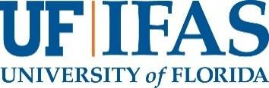
Questions about attending this meeting at GGAA?
Email Andrea Bohn at: abohn@ufl.edu

Agenda for Workshop: Meeting the Challenge of Reducing Enteric CH4 Emissions from Sub-Saharan Africa
Time | Name and affiliation | Title of presentation | Chair/ Facilitator
1:00-1:10 pm | Gbola Adesogan, Feed the Future Innovation Lab for Livestock Systems, University of Florida | Introductory remarks: Introduction to the Innovation Lab and the need to precisely quantify and mitigate GHG emissions from livestock in developing countries.
Session I | Mitigation strategies (15 minutes presentations and 10 minutes discussions)
1:10-1:35 | Ermias Kebreab, University of California Davis | Advances in technologies for reducing enteric methane emission from livestock | Padma
1:35-2:00 | Hayden Montgomery: Special representative, global research alliance on agricultural greenhouse gases  program director – agriculture, global methane hub | Methane Hub and Global Research Alliance on Agricultural Greenhouse Gases
2:00-2:25 | Mulubrhan Balehegn: Feed the Future Innovation Lab for Livestock Systems, University of Florida | Climate smart approaches for reducing GHG emission from small holder livestock sectors in Africa.
2:25-2:50 | Break
Session II | Precise measurement methods for GHG emissions from livestock in developing countries (15 minutes presentations and 10 minutes discussions)
2:50-3:15 | Eneyew Nigussie Finland, Senior Scientist, Animal Genomics & Breeding. Natural Resources Institute Finland (Luke) | The journey less travelled: Methane measurement on a large scale & its mitigation in smallholder livestock production systems | Padma
3:15-3:40 | Claudia Arndt: International Livestock Research Institute, Kenya. | Activities & Research at the Mazingira Centre at ILRI in Kenya
3:40-4:05 | Ouermi Oualyou: Environmental Institute for Agricultural Research - Burkina Faso (INERA), Burkina Faso | Estimating methane emissions from Djallonke Sheep using GreenFeed in Burkina Faso
Session III | Implications for research, policy and development
4:05-4:45 | All participants |  | Gbola

