FEED THE FUTURE INNOVATION LAB FOR LIVESTOCK SYSTEMS

FACILITATOR’S GUIDE

For Implementing a Policy Brief Writeshop

Developed by:

Taryn Devereux, Dr. Renata Serra, and Dr. Nargiza Ludgate

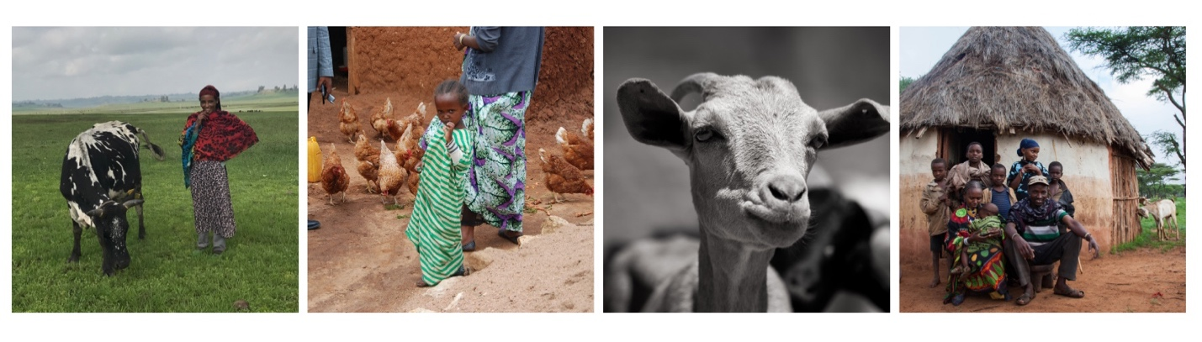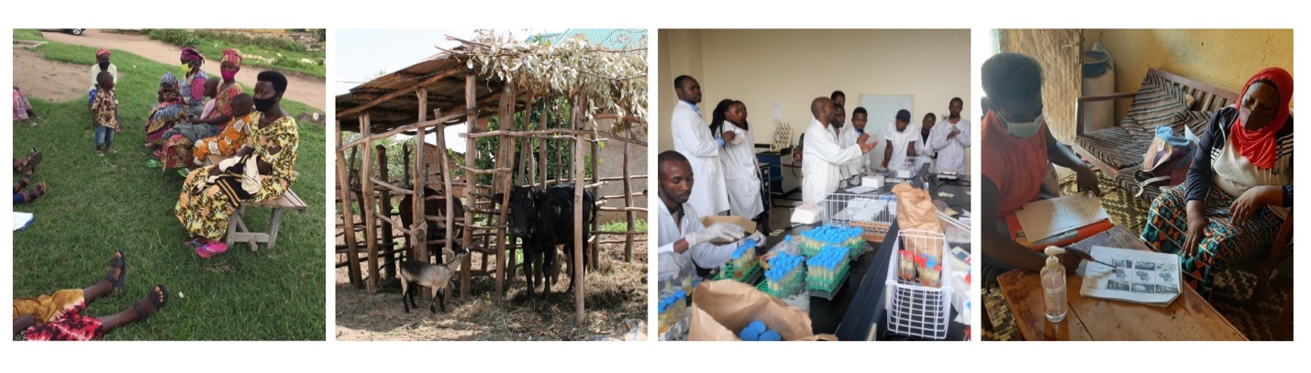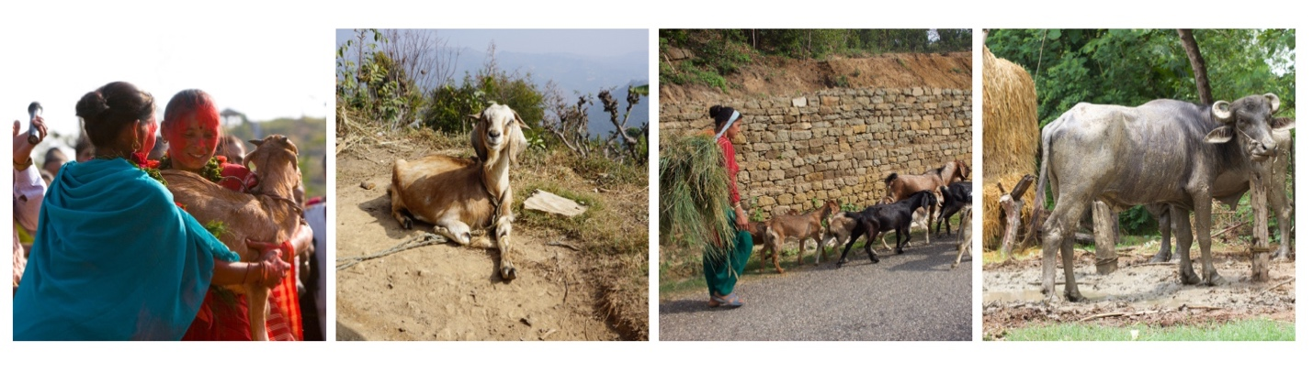November 2024

**Recommended Citation**

Devereux, T., Serra, R., and Ludgate, N. 2024. Facilitator’s Guide for Implementing a Policy Brief Writeshop. Gainesville, FL, USA: Feed the Future Innovation Lab for Livestock Systems.

**Essential Bibliographic Information**

Leader with Associations Cooperative Agreement Award No. AID-OAA-L-15-00003 Sponsored by the USAID Bureau for Resilience, Environment and Food Security.

*Sustainably intensifying smallholder livestock systems to improve human nutrition, health, and incomes.*

**Disclaimer**

This work was funded in whole or part by the United States Agency for International Development (USAID) Bureau for Resilience, Environment and Food Security under Agreement # AID-OAA-L-15-00003 as part of Feed the Future Innovation Lab for Livestock Systems. Additional funding was received from Bill & Melinda Gates Foundation OPP#060115. Any opinions, findings, conclusions, or recommendations expressed here are those of the authors alone.

Photo credits: College of photos from the Feed the Future Innovation Lab for Livestock Systems and from the International Livestock Research Institute.

Table of Contents

Abbreviations 4

About Livestock Systems Innovation Lab 5

About Policy Brief Writeshops 5

Why this guide 6

Our approach to writeshop and learning 7

Preparations before the in-person writeshop 8

Writeshop objectives and agenda 11

Writeshop activities 13

1.1 Registration (30 min) 13

1.2 Welcome and introductions (20 min) 13

1.3 Review agenda and objectives (5 min) 14

1.4 Housekeeping (5 min) 14

2.1 Review: What makes a good policy brief (2-3 min) 14

2.2 Policy brief templates/outline (5 min) 15

2.3 Developing a catchy title (2-3 min) 15

2.4 Choosing your target audience (2-3 min) 15

2.5 Group activity: Targeted audiences (15-20 min) 15

3.1 Presentation: Writing key messages (10 min) 16

3.2 Writing time: Key messages (60 min) 16

4.1 Presentation: Content outline/development (10 min) 17

4.2 Writing time: Develop outline (60 min) 17

5.1 Presentation: Policy recommendations (10 min) 18

5.2 Writing time: Policy recommendations (60 min) 18

6.1 Presentation: Validation and dissemination process (10 min) 19

6.2 Group activity: Develop plans for validation and dissemination (35 min) 20

7 Next steps and wrap-up (30 min) 20

Post-writeshop steps 21

Appendix I: Extra activities and icebreakers 22

Interactive introduction (10-15 minutes) 22

Activity/Review: Making PB headings/titles catchy (15-30 min) 23

Appendix II: Post-writeshop assessment 24

# Abbreviations

CCT Crosscutting theme

EE Enabling Environment

IFAS Institute of Food and Agricultural Sciences

ILRI International Livestock Research Institute

LCD Local Capacity Development

LSIL Feed the Future Innovation Lab for Livestock Systems

PB Policy Brief

UF University of Florida

# About Livestock Systems Innovation Lab

The Feed the Future [Innovation Lab for Livestock Systems](https://livestocklab.ifas.ufl.edu/) (LSIL) develops long-term research and capacity-development efforts, primarily through multi-disciplinary, integrated, and competitively funded applied research. LSIL is one of many innovation labs created by [Feed the Future,](https://www.feedthefuture.gov/feed-the-future-innovation-labs/) and is led by the University of Florida’s [Institute of Food and Agricultural Sciences](https://ifas.ufl.edu/) (IFAS), in partnership with the [International Livestock Research Institute](https://www.ilri.org/) (ILRI). It is funded by the United States Agency for International Development (USAID) and formerly by the Bill & Melinda Gates Foundation. LSIL works in Burkina Faso, Ethiopia, Nepal, Niger, and Rwanda.

The Policy Brief Writeshops is an initiative supported by LSIL under two cross-cutting themes:

* [**Enabling Environment**](https://livestocklab.ifas.ufl.edu/themes/cctee/) (EE)

This theme facilitates research, capacity-building and participatory activities that support the development and implementation of polices and institutional reforms at any level with the aim of enhancing the production, marketing and consumption of animal-source foods, especially among smallholders.

* [**Local Capacity Development**](https://livestocklab.ifas.ufl.edu/themes/cctlcd/) **(LCD)**

This theme facilitates efforts and activities focused on strengthening local partners’ and stakeholders’ capacity within the livestock sector to improve livestock productivity and systems. The LCD activities largely focus on integrating capacity-strengthening efforts across various projects, ensuring a holistic approach to improving livestock systems by addressing educational, institutional, and technical gaps simultaneously.

# About Policy Brief Writeshops

The LSIL **Policy Brief Writeshop is** designed to enable participants from LSIL partner countries to acquire and apply the skills to produce one (or more if desired) policy brief(s) stemming from their LSIL-funded research. Effective policy briefs are documents that communicate interesting project findings, lessons, and policy implications, and engage stakeholders in their actualization.

This writeshop is part of a multi-step process which is described below. The process spans approximately 3 to 6 months, depending on the projects’ respective pace, and consists of in-person and virtual sessions. The main requisite is that two researchers from each project, preferably the Principal Investigator (PI) and Co-PI or another team member, commit to participate from start to end.

The first step requires participants to enroll in, and complete, an online, self-paced course titled, “[Producing Effective Policy Briefs](https://ifas-livestock-innovation-lab.catalog.instructure.com/browse/engaging-stakeholders-in-research-projects/courses/producing-effective-policy-briefs),” offered on the UF/IFAS platform. This free online course provides researchers with the basic knowledge and skills to write effective policy briefs. The course is organized into a short introduction and two learning modules.

Once the basic skills are acquired and learned, participants attend an Introductory Orientation session, which can be held online or in person. This approximately one-hour session introduces participants to the Policy Brief Writeshop format, goals and timeline. This also informs participants about what is needed to prepare ahead of and to bring to the in-person writeshop.

The in-person Policy Brief Writeshop is then held for the participants to put those skills into practice and begin the production of the policy brief. The in-person Writeshop can be half a day (4 hours) or a full-day event (8 hours), depending on the audience’s priorities and time availability. During this interactive event, the participants are introduced to the Policy Brief development process and start to develop key sections of the policy brief with the support of the facilitators. Participants also discuss the next steps following the Writeshop and commit to the process timeline through publication.

The next steps include three online check-in sessions, staggered a few weeks apart, where participants share their progress towards improved versions of their Policy Brief(s) and obtain timely feedback from the facilitators.

The final steps include the validation, the finalization, and the dissemination of the Policy brief, to ensure uptake and follow-up by critical stakeholders.

# Why this guide

This **Facilitator’s Guide** is intended as a working document to guide the delivery of the in-person workshop in partner countries (which is the cornerstone of the whole process as above described). The aim is to provide an adaptive resource for facilitators that can guide future Policy Brief (PB) trainings, before and during the delivery of the writeshop.

This Facilitation Guide is based on PB Writeshops offered in Fall 2024 to LSIL-funded projects in three target countries (Ethiopia, Nepal, and Rwanda), but it is meant to be adapted and utilized in other contexts for similar purposes. This Guide includes suggested agendas, activities, and discussion prompts, and support materials, such as PowerPoint presentations and handouts. You can download the full Guide and supporting materials from [here.](https://livestocklab.ifas.ufl.edu/themes/cctee/policywriteshop)

# Our approach to writeshop and learning

Our overall approach and ethos in this unique training program abide by the following elements and principles. These principles are meant to be discussed with the participants during the opening session of the in-person Writeshop and/or during Virtual Orientations.

**Collaboration: Participants as partners and trainers as facilitators**

* The participants in the writeshop are early to mid-career professionals nominated by LSIL partners, who each bring relevant experience, context, and perspective.
* The trainers are facilitators who share their knowledge and experience while also leveraging the knowledge and experience of the participants.
* The participants and the facilitators should be seen as colleagues and partners, with everyone working together as a respectful team to develop an effective policy brief.
* Our motto for the Policy brief development process is Bottom Up, Not Top Down!

**Participatory, interactive, and fun!**

* Teaching and learning approaches are participatory and interactive, with limited use of lecture-style teaching.
* The writeshop includes discussions, as well as significant time for writing and receiving feedback on the initial Policy Brief draft.
* The participatory nature of the writeshop extends to the online sessions, which include the virtual orientation pre-writeshop, and up to three check-ins.
* Participants are to encourage and support each other’s learning and writing as a peer group, with opportunities for discussion and feedback.

**Promoting lifelong self-directed learning**

* The writeshop aims to strengthen the skills and competencies of LSIL partners in self-directed lifelong learning as part of continued professional development. This includes strengthening skills in online and in-person learning, developing effective Policy Briefs, better understanding the importance of science communication, and using self-reflection to evaluate their learning and progress toward their goals.

**We are all learning: feedback and improvement**

* Constructive feedback, both positive and negative, is welcome at any time.
* OPTIONAL: Facilitators may choose to conduct a pre-assessment among invited participants ahead of the in-person write-shop, in order to gauge topics of interest, previous experience in policy brief writing, and intended PB target audiences.

# Preparations before the in-person writeshop

Choosing a suitable venue for the in-person writeshop is essential, to make sure participants are comfortable in the space and it’s easily accessible. The following preparations should be made in the training room before the in-person writeshop begins:

1. **Creating a shared drive**

Ahead of the in-person writeshop, create a Shared Drive (e.g., Google Drive) to share with participants, containing:

* LSIL PB template options
* Additional reading materials and resources
* Videos, PB examples, and other resources
* Post-writeshop: Slides and other materials used during the in-person writeshop.
* This shared drive will be used later by both lead authors of the policy briefs and facilitators to exchange different versions of the policy brief.

1. **Arrangement of tables and room**

Arrange tables as in this picture to facilitate group spirit. This will enable participants to split into even groups and make it easy for facilitators to move between tables during writing times.

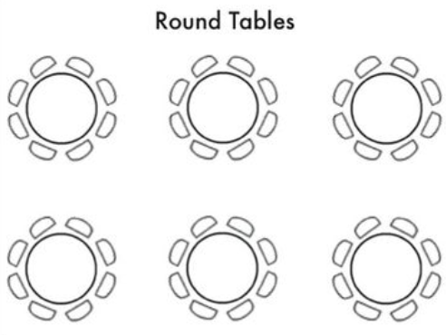

Ensure sufficient seating for your planned number of participants. Make sure that the room has space to do energizers.

If possible, have a room where at least one or two of the walls are empty to hang/stick flipcharts after each session where flipcharts are used. This will allow participants to review flipcharts after the session, during breaks, or at the end of the day.

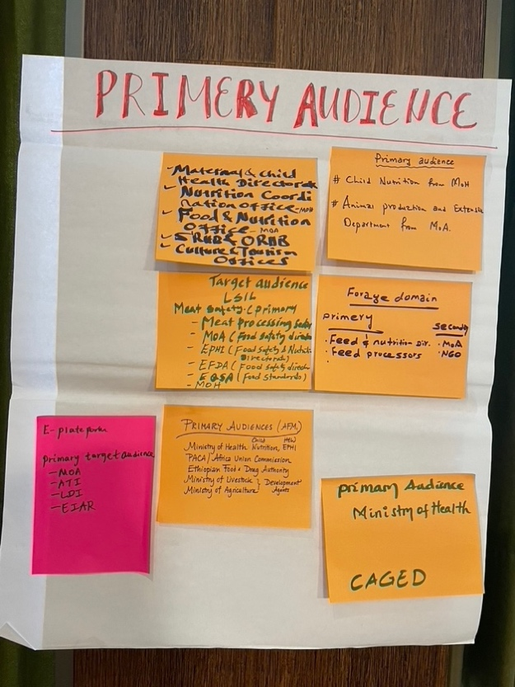

1. **Equipment and supplies required in the room:**
   * Computer and projector,
   * A screen or white wall to project a presentation,
   * Ensure WiFi is available; have WiFi name and password if needed clearly written on a flipchart or other accessible sign,
   * Ensure two or three multi-outlet power extension cords are available for participants to connect their laptops during the writeshop,
   * Ensure one or two flipcharts are available to take notes or distribute to participants for any group work,
   * One or two stands for flipcharts,
   * 20 color markers,
   * Large post-it notes and/or pieces of colored card and sticky tape (to affix card to flipchart if necessary),
   * Banners advertising the writeshop and institution if applicable.
   * Optional: At the writeshop: provide participants with a notebook, pen, and printed agenda
2. **Participant Registration**
   * Register attendance at the start and collect consent form for taking and sharing participant photos (if applicable).
   * Provide participants with name badges or folded paper/cards to write their names and place onto desks (the latter may be preferred to name badges if names are to be read across the room).
3. **Other (if applicable)**
   * Ahead of the writeshop, prepare 2-4 policy brief template options for your participants. This can include 2- and 4-page versions of the template, as well as LSIL (or project) branded versions and non-branded versions. If the resources are available, work with a designer to create these options, to also ensure they are easily editable. These templates can be shared either ahead of or at the beginning of the in-person writeshop day.
   * A week before the writeshop, send a reminder to participants instructing them when the writeshop starts, the address of the venue, and share the writeshop agenda. Also, request that participants bring their laptops to use during the writing sessions.
   * If you are co-hosting the writeshop with a target country partner, please review the protocol for speakers:
     1. [If applicable] Identify a person (facilitator and/or local coordinator) to do Opening Remarks at the beginning of the writeshop, and Closing Remarks at the end of the day. Prepare speaking points or key messages for this person to relay to participants.
     2. When scheduling the writeshop and finalizing your agenda, consider local holidays, traditional meal schedules, and other aspects of the cultural context.

# Writeshop objectives and agenda

This guide has been built on a six-hour writeshop event – but can be adapted to a shorter (4 hours) or a longer (8 hours) session. Content includes presentations on different sections of the policy brief, such as creating a brief heading, key messages, and recommendations, ample time for group discussions, and independent writing time. The writeshop agenda can be adapted to better address the unique needs and interests of a group of participants.

**WRITESHOP OBJECTIVES**

1. Introduce LSIL partners to the policy brief development process
2. Share policy brief template(s)
3. Develop Heading, Key Messages, and at least one other section (e.g., Key Recommendations)
4. Consider and plan for PB content outline
5. Discuss the next steps and commit to the timeline

**WRITESHOP OUTCOMES**

By the end of the writeshop, participants will have:

* Understood the purpose and importance of effective policy brief writing.
* Identified and set expectations for the PB writing process.
* Made progress on policy brief development and committed to a publication timeline.
* Identified key stakeholders and target audiences to share PBs with, including drafting a validation and dissemination plan.
* Strengthened LSIL network and collaborations within the target country.

**AGENDA**

|  |  |  |
| --- | --- | --- |
| **Time** | **Session #** | **Activity** |
|  | **Set-up** | * Room arrangement * Equipment & Materials (e.g. flipcharts) * Registration desk |
| 30 min | **Registration** | Participant registration |
| 30 min | **Introductions** | 1.1. Welcome & Introductions  1.2. Review Agenda & Objectives  1.3. Housekeeping (bathrooms, breaks, etc.) |
| 30 min | **Title and Audience** | 2.1. Review: What makes a good policy brief  2.2. Policy brief templates / outline  2.3. Developing a catchy title  2.4. Choosing your Target Audience  2.5. Group Activity: Target Audiences |
| 15 min | **Coffee Break** | |
| 70 min | **Key Messages** | 3.1. Presentation: Writing Key Messages  3.2. Writing Time: Key Messages |
| 70 min | **Content Development** | 4.1. Presentation: Content Outline / Development  4.2. Writing Time: Develop Outline |
| 1 hour | **Lunch** | |
| 70 min | **Policy Recommendations** | 5.1. Presentation: Policy Recommendations  5.2. Writing Time: Policy Recommendations |
| 45 min | **Validation & Dissemination** | 6.1. Presentation: Validation & Dissemination Process  6.2. Group Work: Developing Plans for Validation & Dissemination |
| 30 min | **Conclusion** | 7. Next Steps and Wrap-up |
| **Adjourn** | | |

# Writeshop activities

This section corresponds with the agenda presented above, to provide facilitator cues and discussion prompts, and to indicate where materials and resources (e.g. PowerPoint slides) can be integrated and applied.

## 1.1 Registration (30 min)

Facilitator: Welcome participants to the writeshop. Provide the objectives / agenda handout. Provide badges or foldable papers for the name card. Provide pen / notebooks. (If applicable) receive consent to be photographed during the writeshop.

## 1.2 Welcome and introductions (20 min)

Facilitator: Use **PB Writeshop – Welcome – PowerPoint slide.** Adapt below text as necessary to convey key message and introduce facilitators.

*Hello and welcome. This* ***Policy Brief writeshop*** *is designed for researchers from Livestock Systems Innovation Lab (LSIL) partner projects working in _________ [indicate country]. This writeshop is designed for participants to acquire and apply the skills to produce one (or more) policy brief(s) stemming from your LSIL-funded research.*

*Created by Feed the Future, the Livestock Systems Innovation Lab at the University of Florida develops long-term research and capacity-development efforts, primarily through multi-disciplinary, integrated, and competitively funded applied research. We support nearly 50 projects using innovative approaches to address country-specific research priorities, in concern with national stakeholders.*

*Our mission for the Policy Briefs is to capture the innovative research conducted through your projects. By communicating your findings, you are transferring essential knowledge that can help concerned actors, particularly policymakers, make informed decisions. As experts in your field, you can provide persuasive advice to target audiences to solve critical challenges in livestock systems.*

Go to **PB Writeshop – Who We Are – PowerPoint slide.**

*Your facilitators today are:*

Have each facilitator introduce themselves, including name, title, organization, and training background.

[If applicable] the in-country coordinator can also provide a short official welcome and remarks. Ideas for speaking points include:

* Warm welcome to participants
* Short description of roles of host institution
* Good wishes for active involvement of participants in the training

Using the **PB Writeshop – Introductions - PowerPoint slide**, ask the group of participants to introduce themselves by sharing their **name, institution & project.** If desired, a longer introduction icebreaker activity is available in the Appendix.

## 1.3 Review agenda and objectives (5 min)

Facilitator: Go to **PB Writeshop – Writeshop Objectives – PowerPoint slide.**

Give a brief overview of the agenda. Highlight the different sessions, start/finish times, and breaks. Explain that some sessions or timing might change to meet the needs of the group. Address questions the participants may have regarding the agenda.

Walk participants through each objective. Answer any of the participants’ questions, comments or concerns.

## 1.4 Housekeeping (5 min)

Facilitator: Provide information on bathroom locations & reiterate the scheduled breaks. Point out the WiFi login/password noted on the flipchart. Ask if there are any issues logging into the network. Answer any of the participants’ questions, comments or concerns.

## 2.1 Review: What makes a good policy brief (2-3 min)

Facilitator: Go to **PB Writeshop – What Makes a Good Policy Brief? - PowerPoint slide** to walk participants through key points. Adapt text as necessary.

Key Takeaways:

* A good Policy Brief is a clear and concise stand-alone document that addresses a single, specific topic and summarizes a particular issue.
* It makes a case for why this is relevant and provides evidence-based policy options to deal with the issue, and if possible, some recommendations on possible ways forward.
* Effective Policy Briefs are concise and easily understood; Focused on a specific issue or problem; are evidence-based; accessible to target audiences; and action/policy oriented.

## 2.2 Policy brief templates/outline (5 min)

Facilitator: Use **PB Writeshop – Policy Brief Template – PowerPoint slide** to walk participants through key points. Adapt text as necessary.

*During today’s writeshop, you will complete your PB Heading & Key Messages and will draft parts of or outline the rest of your document.*

If you have not already done so, ensure that all participants can access the Shared Drive with the LSIL Policy Brief templates and can download them to their devices.

## 2.3 Developing a catchy title (2-3 min)

Facilitator: Use **PB Writeshop – Title Template – PowerPoint slide** to walk participants through key points. Adapt text as necessary.

Key Takeaways:

* Titles must be short, descriptive, and catchy
* They can indicate your policy recommendations
* You may have a title (general overview) and a subtitle for more specific explanations

## 2.4 Choosing your target audience (2-3 min)

Facilitator: Use **PB Writeshop – Choosing Your Target Audience – PowerPoint slide** to walk participants through key points. Adapt text below as necessary.

*Stakeholders are people who have a stake in, may affect, or be affected by the policy implications of your project. This includes communities, industries, decision-makers, policymakers, state agencies, etc. Think of a “role” or “team” you want to target, rather than a specific individual person.*

## 2.5 Group activity: Targeted audiences (15-20 min)

Facilitator: Use **PB Writeshop – Interactive Activity PowerPoint slide**. Adapt text below as necessary.

*You are to map and list who these actors are, as they will be the ultimate users / target of your policy brief. Break into small groups, write on stickies and add to the flipchart:*

* *What is your Policy Brief Title?*
* *Who is your primary audience for this Policy Brief?*
* *Do you have any secondary audiences? Who is your secondary audience?*

After completing the exercise, hang the flipchart / paper with notes taken somewhere on the wall where it will be visible throughout the workshop.

Coffee break (15 min)

Facilitator: Announce that the group will now take a 15-minute break. Provide reminders about the location(s) of the available restrooms. Be available for any questions or concerns.

3.1 Presentation: Writing key messages (10 min)

Facilitator: Use **PB Writeshop – Key Messages – PowerPoint slides** to walk participants through key points. Adapt text as necessary.

Central question: *What are the key takeaways from your research / initiative, for your target audience(s)*

Key Takeaways:

* Key Messages are a short, bullet-pointed list that summarize the most important take-home message(s)
* This is the main point of information you want your audience to hear, understand and remember
* Limit to 2 or 3 simple key messages that link back to your Policy Recommendations

## 3.2 Writing time: Key messages (60 min)

Facilitator: Use **PB Writeshop – Key Messages Writing Time PowerPoint slide.** Introduce the first writing session for the day. Explain the purpose of this writing time. Participants will have approx. 60 minutes to work on their policy brief titles and key messages. Note the current time and the time you will regroup. If there is enough time at the end, participants will regroup and ask 1-2 volunteers to share their Title and Key messages and how those connect with their target audiences.

Participants are to work independently unless they are collaborating on a policy brief. Facilitators will be circling the room to provide guidance and answer any questions.

Ensure that participants have one-on-one time with at least one facilitator during this time. Facilitators should note any common questions.

If there is time for the Share & Listen, after each share, ask the group for any feedback. Address this feedback and provide additional feedback, as appropriate.

## 4.1 Presentation: Content outline/development (10 min)

Facilitator: Use **PB Writeshop – Content Outline / Development PowerPoint slide** to walk participants through key points. Adapt text as necessary.

Key Takeaways:

* Consider how you can describe the problem to be addressed throughout the entire structure of your PB
* Be targeted and selective: include what’s needed for your audience to understand the meaning of your work, and research finding or activities that speak directly to your problem
* Consider how you might share your research findings and implications with a friend or family member outside your field – what type of language would you use?

## 4.2 Writing time: Develop outline (60 min)

Facilitator: Use **PB Writeshop – Outline Writing Time PowerPoint slide** to walk participants through key points. Adapt text as necessary.

Introduce the next writing session for the day. Explain the purpose of this writing time. Participants will have approx. 60 minutes to outline the main content of their policy briefs. Note the current time and the time you will regroup. If there is enough time at the end, participants will regroup and ask 1-2 volunteers to share their PB outline.

Participants are to work independently unless they are collaborating on a policy brief. Facilitators will be circling the room to provide guidance and answer any questions.

Ensure that participants have one-on-one time with at least one facilitator during this time. Facilitators should note any common questions.

If there is time for the Share & Listen, after each share, ask the group for any feedback. Address this feedback and provide additional feedback, as appropriate.

Lunch break (60 min)

Facilitator: Announce that the group will now take a 60-minute lunch. Provide reminders about the location(s) of the available restrooms. Be available for any questions or concerns.

## 5.1 Presentation: Policy recommendations (10 min)

Facilitator: Use **PB Writeshop – Policy Recommendations PowerPoint slides** to walk participants through key points. Adapt text as necessary.

**Central question**: *What makes recommendations realistic and actionable?*

Key Takeaways:

* Link your Recommendations back to your Key Messages
* Provide alternative actions to be taken to address the current situation. State clearly with action verbs and associated conditions / assumptions
* Indicate realistic effects of policy implications that are supported by your research. Explain the different options to improve the situation

## 5.2 Writing time: Policy recommendations (60 min)

Facilitator: Use **Policy Writeshop – Policy Recommendations Writing Time PowerPoint slide** to walk participants through key points. Adapt text as necessary.

Introduce the next writing session for the day. Explain the purpose of this writing time. Participants will have approx. 60 minutes to work on their policy recommendations. Note the current time and the time you will regroup. If there is enough time at the end, participants will regroup and ask 1-2 volunteers to share their PB outline.

Participants are to work independently unless they are collaborating on a policy brief. Facilitators will be circling the room to provide guidance and answer any questions.

Ensure that participants have one-on-one time with at least one facilitator during this time. Facilitators should note any common questions.

If there is time for the Share & Listen, after each share, ask the group for any feedback. Address this feedback and provide additional feedback, as appropriate.

## 6.1 Presentation: Validation and dissemination process (10 min)

Facilitator: Use **Policy Writeshop – Validation & Dissemination PowerPoint slides** to walk participants through key points. Adapt text as necessary.

Key Takeaways: Policy Brief Validation

* Validation is the process of ensuring the policy brief contains all the relevant information to be understood properly and adopted by specific target audiences
* The process may be lengthy, but it ensures improved acceptance of the brief and the likelihood of implementation of the recommendations
* Host a Validation Workshop: an efficient and participatory process between the research team and the primary target audience
* Validation Steps: 1) Review purpose, audience, content/structure; 2) Gather feedback; 3) Analyze feedback; 4) Incorporate feedback for improvement

Key Takeaways: Policy Brief Dissemination

* Dissemination is the process of making a policy brief accessible to a target audience through various communication channels such as publications, meetings, conferences, workshops, websites, social media, etc.
* Intentional policy brief dissemination ensures accessibility and uptake of the implications and recommendations by policy makers, your target audience, and other stakeholders.
* Dissemination conducted at every favorable opportunity to get it out and reach any of your intended audience in an effective way. It is not a one-time activity, but rather an ongoing relationship with your stakeholders.
* Create a Dissemination Plan: determine your target audiences; identify dissemination channels, create alternative methods for access (e.g. online, downloadable); work with targeted leaders & networks; evaluate the reach and effectiveness of your dissemination

## 6.2 Group activity: Develop plans for validation and dissemination (35 min)

Facilitator: Use **Policy Writeshop – Creating a Plan PowerPoint slide** to walk participants through key points. Adapt text as necessary.

Pending time availability, ask participants to now break into groups to brainstorm ideas for creating a plan for validation and dissemination. Each group will have its flipchart, stickies, and markers for writing ideas down. Facilitators should circle the room during the activity to provide guidance and feedback.

Prompt: *What is the best way to reach your target audience(s)?*

## 7 Next steps and wrap-up (30 min)

Facilitator: Use **Policy Writeshop – Next Steps PowerPoint slides** to walk participants through key points. Adapt text as necessary.

* Policy Brief Development Timeline
* Lead Author
* Questions, Concerns & Suggestions

Review the participants’ commitment to the timeline to complete their Policy Briefs. Address any questions or concerns.

Time pending, share the Exit Survey link at the close of the day. The survey will take approximately 5 minutes of participants’ time.

**Adjourn**

Use **Policy Writeshop – Thank You PowerPoint slide.**

Post-writeshop steps

* Send a collective email to all participants to thank them for their participation and to share writeshop slides & other materials via Google / Shared Drive.
* Remind participants to complete the writeshop exit survey (Appendix II), if they have not done so.
* Send additional reminders about the next steps, including the first scheduled virtual check-in.

# Appendix I: Extra activities and icebreakers

## Interactive introduction (10-15 minutes)

Pending time, facilitators can extend the quick introductions (Name, Institute, Project) into an interactive activity in order to better acquaint participants with one another and foster group comradery.

Facilitator: Ask participants to pair up (ideally with someone they don’t know). Give participants 3 minutes: 1-1½ minutes for each participant to introduce themselves in a pair. Ask pairs to have a quick conversation about each other based on the prompts below and inform them that they will later introduce each other.

* Name
* What they do / project they work on
* One trait important to being an agriculture and/or livestock specialist (e.g. A good communicator)
* One fun fact about themselves (e.g. I like singing)

Facilitators should write the above points on the flipchart so that everyone can remember what they need to ask their pair.

After 3 minutes, go around the group and let everyone introduce their pair. The facilitator captures notes about the important traits participants share on the flip chart.

If there are two facilitators in the room, they should also introduce each other in the same way.

After completing the exercise, hang the flipchart/paper with notes taken somewhere on the wall where it will be visible throughout the workshop.

Finally, make sure all participants have on their name tag, or folded paper or card with their name written visible on the table in front of them. Remind participants to have it throughout the workshop.

## Activity/Review: Making PB headings/titles catchy (15-30 min)

Based on feedback from country project leads, the virtual orientation, and/or the pre-writeshop assessment, facilitators may choose to also include a small section on best practices for writing the PB Heading / Title. This can reinforce information shared during the online course.

Facilitator: Use **Policy Writeshop – Heading / Titles PowerPoint slide** to walk participants through key points. Adapt text as necessary.

Key Points:

* Must be short, descriptive, and catch
* May indicate your policy recommendations.
* Options:
  + Ask a question in the title to entice someone to reach (e.g. “Why population growth matters for sustainable development?”
  + Combine the main topics discussed in the policy brief (e.g. “Population, food security, nutrition, and sustainable development”)
  + Use a main title for a general overview, and a subtitle for more specific recommendations (e.g. “Rising food prices: a global crisis – action needed now to avert poverty and hunger”)

Provide participants with 10-30 minutes (depending on time availability) to workshop their PB Headings / Titles. Regroup and ask either 1-2 participants, or the entire group (again, pending time) to share their Titles for feedback.

**Open write time: Writing and feedback from the LSIL team (60 min)**

Based on feedback from country project leads, the virtual orientation, and/or the pre-writeshop assessment, and pending time available, facilitators may choose to also include a separate open writing block at the end of the writeshop for participants to continue working on any section of their PB, and/or Validation & Dissemination Plans.

Facilitator: *Any who needs to leave can now do so. The next hour will be an open session for participants to work on any component of their Policy Brief, ask questions of the facilitators, or work on their Validation & Dissemination Plans.*

# Appendix II: Post-writeshop assessment

The purpose of this survey is to gather feedback from participants of workshops held by the Feed the Future Innovation Lab for Livestock Systems. Feedback will be used to continuously learn from and improve these workshops. This survey should take approximately 3 minutes to complete and the answers you provide will remain confidential and anonymous. Thank you for your time!

Involvement: Please select your involvement in the Livestock Systems Innovation Lab.

 Project Principal Investigator (PI) or Co-PI

 Project Collaborator

 Other Lab Stakeholder (please describe): _____________

Affiliation: Which of the following categories best describes your affiliation?

 Government

 Research Organization

 Private Sector

 Academia

 Non-governmental organization

 Other (please describe): _____________

Objectives: Please use the scale provided below to indicate your level of agreement or disagreement with each of the following statements. If any statement is not applicable, please mark the box in the column “Not Applicable."

Regarding the **workshop objectives** would you say ...

|  |  |  |  |  |  |  |
| --- | --- | --- | --- | --- | --- | --- |
|  | Strongly Disagree | Disagree | Neutral | Agree | Strongly Agree | Not Applicable |
| The overall purpose of the workshop was clear |  |  |  |  |  |  |
| The specific objectives of the workshop were clear |  |  |  |  |  |  |
| I believe the specific objectives of the workshop were accomplished |  |  |  |  |  |  |

Regarding **knowledge sharing and discussion** would you say ...

|  |  |  |  |  |  |  |
| --- | --- | --- | --- | --- | --- | --- |
|  | Strongly Disagree | Disagree | Neutral | Agree | Strongly Agree | Not Applicable |
| I learned new information about writing policy briefs I did not know previously |  |  |  |  |  |  |
| I strengthened my existing knowledge of topics related to policy brief writing |  |  |  |  |  |  |
| I was able to contribute meaningfully to discussions |  |  |  |  |  |  |
| I was able to interact with other attendees in meaningful ways |  |  |  |  |  |  |

Regarding the **workshop outcomes** would you say ...

|  |  |  |  |  |  |  |
| --- | --- | --- | --- | --- | --- | --- |
|  | Strongly Disagree | Disagree | Neutral | Agree | Strongly Agree | Not Applicable |
| My personal expectations for attending the workshop were met |  |  |  |  |  |  |
| I improved my skills related to policy brief writing |  |  |  |  |  |  |
| I made new professional connections |  |  |  |  |  |  |
| I strengthened existing professional relationships |  |  |  |  |  |  |
| The next steps of this meeting are clear |  |  |  |  |  |  |

Before today’s workshop, had you ever attended previous trainings on communicating to policymakers?

 Yes

 No

[If YES] When did you attend this training?

_________________________

[If YES] Who organized this other training?

_________________________

[If YES] How would you compare today’s policy brief workshop to this past training you experienced?

____________________________________________________________________________

____________________________________________________________________________

____________________________________________________________________________

____________________________________________________________________________

What was the most enjoyable part of the meeting and why?

____________________________________________________________________________

____________________________________________________________________________

____________________________________________________________________________

____________________________________________________________________________

What was the least enjoyable part of the meeting and why?

____________________________________________________________________________

____________________________________________________________________________

____________________________________________________________________________

____________________________________________________________________________

Do you have any advice on how these meetings could be improved?

____________________________________________________________________________

____________________________________________________________________________

____________________________________________________________________________

____________________________________________________________________________

Whom else should we invite to similar meetings in the future? Who else should be involved for the next steps?

____________________________________________________________________________

____________________________________________________________________________

____________________________________________________________________________

____________________________________________________________________________

If you have any other comments, questions, or suggestions, please describe them below.

____________________________________________________________________________

____________________________________________________________________________

____________________________________________________________________________

____________________________________________________________________________

We thank you for your time spent taking this survey. Your response has been recorded.